**Marketing Channels Modeling With Synergy**

**Executive Summary**

In this paper, multiple models are applied to study the empirical effects of advertisements on sales promotion. In the first place, we categorized the offline and online advertising channels into 8 pipelines and differentiated the sales records to make sure it’s a stationary OLS regression. On the basis of the explanatory variables’ correlation graphs, we distinguished these variables that showed high inter-correlations. Then we created synergized variables in regression equations to study the potential reciprocal effects. The regressive algorithm focuses on both static and dynamic effects: the static model studies how an individual advertising approach will change the sales amount when ceteris paribus; The dynamic regression provides the evidences about how different channels will amplify or impair the final promotion scales. After the regression analysis, we also give justifications for the model we selected and derive the substitution elasticity among different advertising channels.

**Model Development and Testing**

In order to come up a model cohere to business sense and statistical logic, we followed the following steps in variable considerations.

Step 1: Before creating linear models to assess the elasticities of marketing channels, we assess the correlations between each marketing channels to find whether we can develop models according to the highly correlated channels. The Model 5 was created based on this method. (Appendix *)

Step2: After that, we decided to exclude Social_Network and Retargeting channels as they are either empty or having too few values to be included in a model. Therefore, model 1 to 12 are valued without these two channels.

Step2: Our team uses business sense in developing the remaining models: model 1 to 4 and model 6 to 11. The detailed explanation will be discussed after this session.

Step 3: We evaluated AIC value of each model and within the models that has less than 2 points in AIC value differences then R-square is used as second tier selection criteria. The rule of thumb that we followed is the smaller the AIC, the better the model is representing the channels and total sales. Within the models having AIC less than 2 points in difference, we took the model with highest R-square.

Step 4: Examine the correctness of the models and select the one that has minimum negative beta, and optimally, one without negative beta.

**Business Sense behind each model:**

Each model are tested with interception and without interception. Our assumption on doing so is that we believe business will make sales even without any expenditure in advertising channels.

**Model 1:**  We believed that online and offline purchase method would have effects on sales. We wanted to compare the total expenses online vs offline marketing to find out how much each marketing method contributes to the sales. Therefore, we aggregated total expenses online and total expense offline to build a linear model with Sales.

R Script:

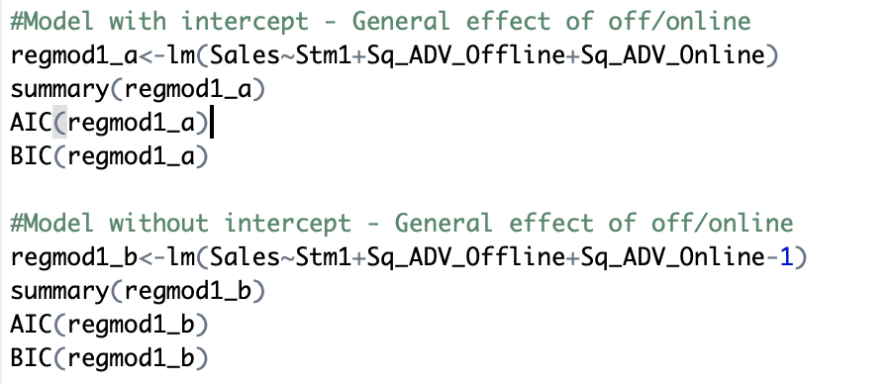

**Model 2:**  In this model, we include all factors that could have effects on sales. This model provides us with a general effects of all factor. By running this model we can have a sense of which factors should we keep and develop other models to find its detail effects.

**Model 3:** In this model, we only included online factors. We could find which online factors have more effects on sales. For instance, during online service, what kind of effect would sending emails to customers asserts on sales.

**Model 4:**  In this model, we only included offline factors. From this model, we could find which offline factors have more effects on sales. In offline cases, we consider factors like sending customer newsletter in the mail.

**Model 5:** In this model, we choose factors based on model 1~ 4. We selected factors which have high correlations in the former models and put them into one model to see their effect on sales.

**Model 6:** This models is developed because we believe customers who have exposures to the company’s products will have a general idea of what the brand is about and what products does the company sell. In later days, these customers who has exposure to the product will have a image reinforcement when receiving catalogs from the company. Therefore, in this model, all offline channels are listed and total online expenditure are multiplied with each offline channels.

**Model 7:** This model is developed to access how offline marketing expenditure will synergize with each online marketing expenditures. In a similar fashion to model 6, individual online channels are included in the model as well as offline total multiplied with each online channels。

**Model 8:** We believe that online search will have substantial effect on customer to make purchasing decisions after they receiving mailed catalogs. Therefore, we decided to access the synergy effects of online search to all offline channels.

**Model 9:** This model is developed based on a scenario: a customer received the online newsletter and saw a new headphone is released. Days latter, the customer went to google.com and search for the new headphone and same product shows up on the first line. The Customer clicked on the search ad for more details and make a purchase. Base on this scenario, we think newsletter and search will have synergy with search.

**Model 10:** After testing the above models, we found Model 1b is potentially a appropriate model to for the marketing channel analysis but we want to examine the effect of the retargeting channel that we excluded. This model is aiming to examine if excluding the retargeting channel is a correct assumption.

**Model 11:** In theory, we believe the retargeting channel is a effective way to gain customers’ attentions as it gave customers a second exposure of the product names and might lead the customer to search for those products for purchase.

**Model 12:** After running and comparing the 11 models we developed above, we narrowed down to model 1b online total and offline total as it is the only model that has all positive betas. Therefore, we tested the synergy effect of the online and offline.

**Winning Model: Elasticity and Suggested Expenses Allocation**

After testing and comparing the outcome of the model based on AIC value, R-square and numbers of negative betas. We have determined that Model 1b is optimum to evaluate the synergy between offline and online factors. After running the code(Appendix 2), the elasticity and allocation of each factor can be viewed as below. The Elasticity of offline and online promotion are relatively 34.81113 and 6.941323, based on which we can suggest to allocate 83% of the resources to offline promotion and 16.7% resources to online promotion. It make sense as in online marketing is usually cost-efficient. 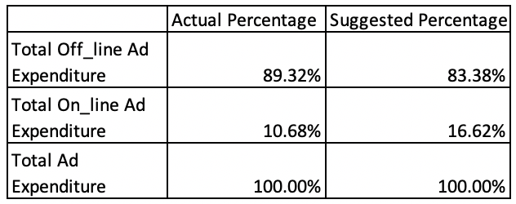

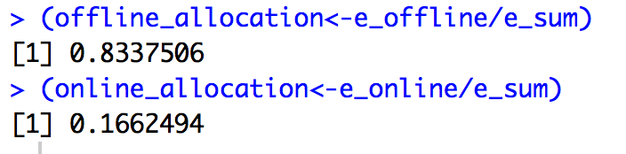

**Summary**

After examining results of each models, we filtered out a optimum model to represent the marketing channel analysis. Based on our assessment, it is highly possible that there is no substantial synergy effects between each channels. Even though we tried to use different combination of channels to find synergy effects among marketing channels. We ended up choosing the one with no synergy effect mainly due to the fact that introducing multiplication of variables increases the noises among the channels. These noises might be reduced or eliminated after obtaining substantial records of each channels versus having only 42 rows of data. Until then, this report will conclude our marketing channel modeling.

**Appendix**

Appendix *

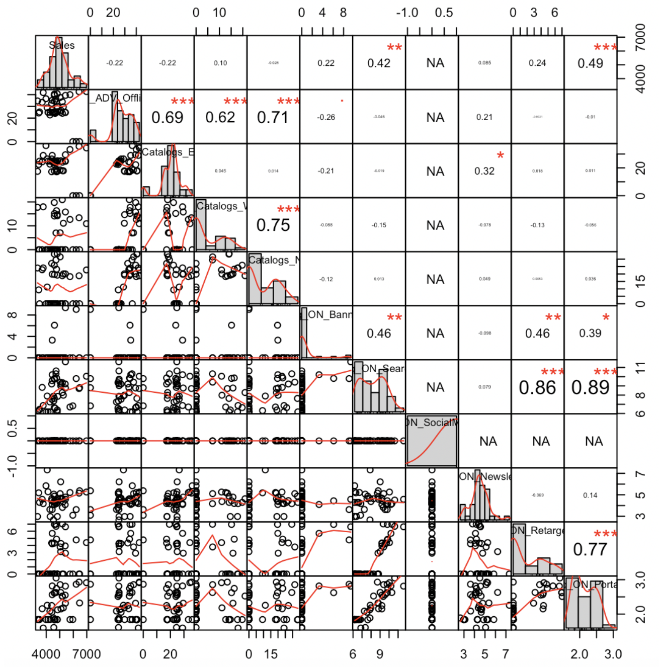

Appendix 1: Model Comparison Table

|  |  |  |  |
| --- | --- | --- | --- |
| **Regression Models** | **AIC** | **Number of**  **Negative Beta** | **R^2** |
| **Regression Model 1 – w. intercept** | **664.6756** | **1** | **0.1187** |
| **Regression Model 1 – w/o intercept** | **674.4107** | **0** | **0.9699** |
| **Regression Model 2 – w. intercept** | **662.9584** | **3** | **0.2343** |
| **Regression Model 2– w/o intercept** | **664.9438** | **2** | **0.9785** |
| **Regression Model 3 – w. intercept** | **664.5005** | **2** | **0.175** |
| **Regression Model 3 – w/o intercept** | **668.0632** | **1** | **0.9758** |
| **Regression Model 4 – w. intercept** | **662.4203** | **2** | **0.2002** |
| **Regression Model 4 – w/o intercept** | **669.9880** | **2** | **0.9742** |
| **Regression Model 5 – w. intercept** | **664.5553** | **1** | **0.1399** |
| **Regression Model 5 – w/o intercept** | **670.8215** | **1** | **0.9731** |
| **Regression Model 6 – w. intercept** | **670.4277** | **5** | **0.1111** |
| **Regression Model 6 – w/o intercept** | **673.8368** | **4** | **0.9742** |
| **Regression Model 7 – w. intercept** | **656.5317** | **4** | **0.3454** |
| **Regression Model 7 – w/o intercept** | **659.1867** | **3** | **0.9813** |
| **Regression Model 8 – w. intercept** | **668.5622** | **5** | **0.1746** |
| **Regression Model 8 – w/o intercept** | **670.9297** | **4** | **0.9767** |
| **Regression Model 9 – w. intercept** | **664.3602** | **5** | **0.2211** |
| **Regression Model 9 – w/o intercept** | **664.1255** | **4** | **0.9793** |
| **Regression Model 10 – w. intercept** | **663.727** | **4** | **0.233** |
| **Regression Model 10 – w/o intercept** | **663.7052** | **4** | **0.9795** |
| **Regression Model 11 – w. intercept** | **665.0675** | **4** | **0.2201** |
| **Regression Model 11 – w/o intercept** | **664.6993** | **4** | **0.9793** |
| **Regression Model 12a – w. intercept** | **666.532** | **2** | **0.1331** |
| **Regression Model 12b – w. intercept** | **666.5591** | **1** | **0.0968** |
|  |  |  |  |
|  |  |  |  |

**Appendix 2**

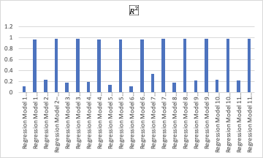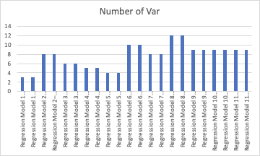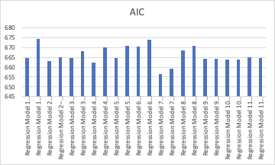

**Appendix 3 Elasticity and Allocation - RScript**

